Assignment #1

* I downloaded the file spurs.jpg and drake.mp3 and installed the HxD Hex Editor to help me with the analysis.

1. I located offset: 0x4AC92 (Big Endian). In the ASCII table it showed the “yardhosue-8pm”.

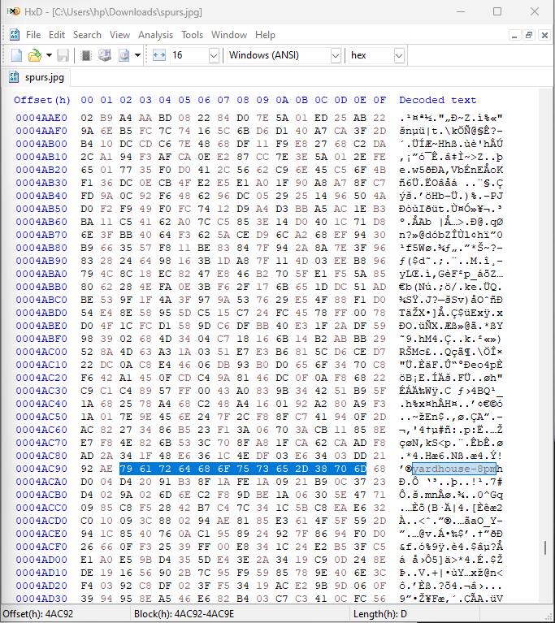



Where and what time is the sleeper cell meeting on 9/4? In the yard house at 8pm

* I then inserted the drake.mp3 into the editor and found the offset given: 0x00000.

1. I modified the word 0x4E59 to 0X4D5A. Then, I saved it as drake2.exe.

**Before:**

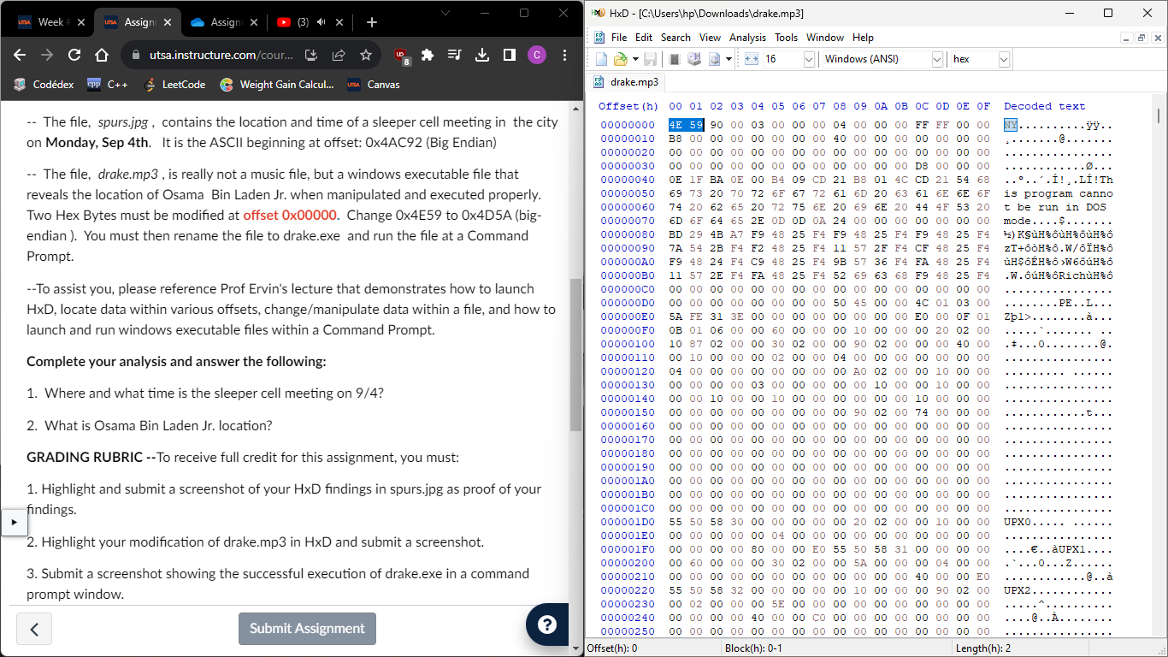



**After:**

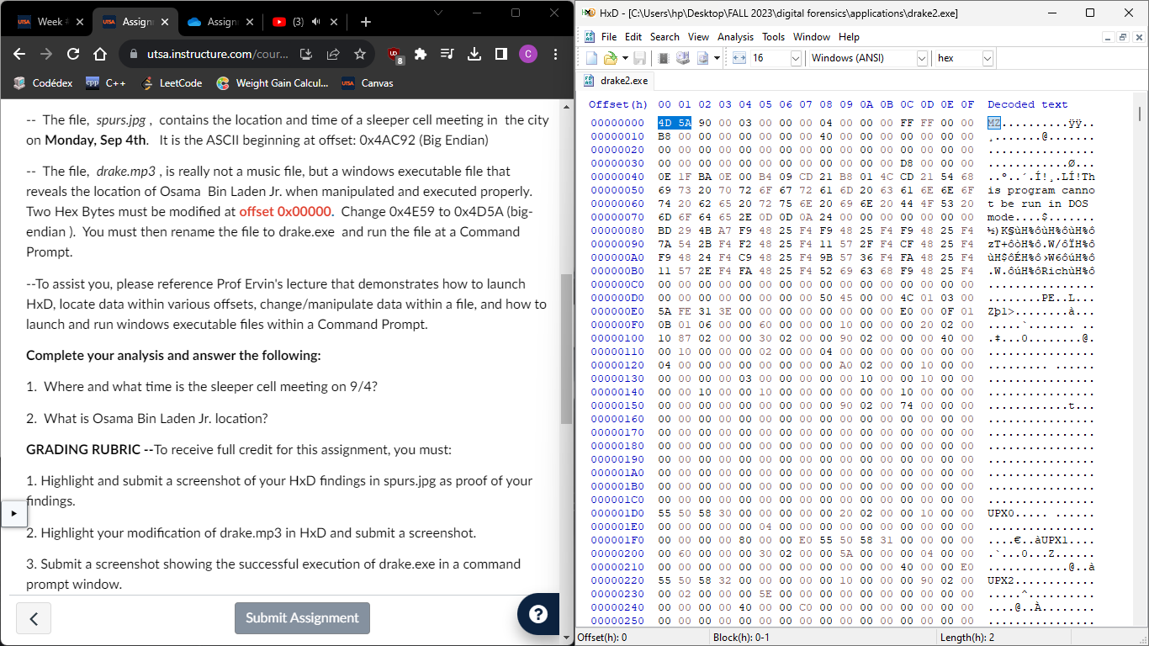



* I went to my command prompt and went to the directory where my new executable file was, which Is: “C:\Users\hp\Desktop\FALL 2023\digital forensics\applications”.
* Then I typed drake2.exe to execute the modified program.

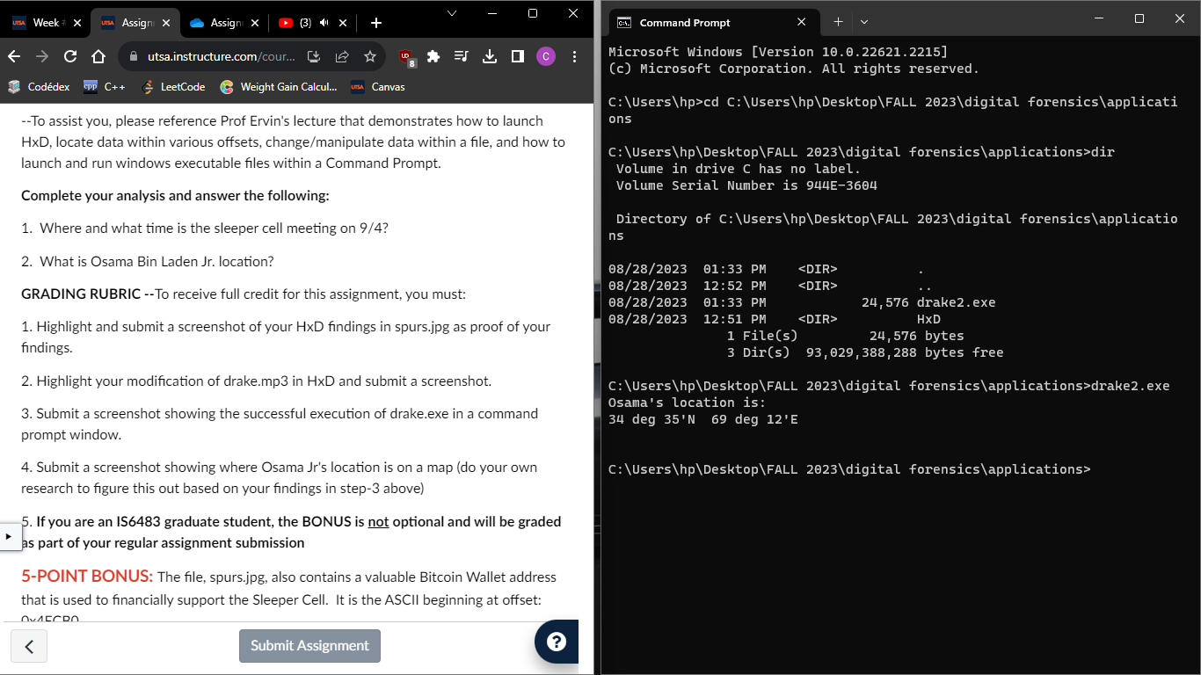



* Coordinates are **34 deg 35’N 69 deg 12’E**
* I did my research and was able to find an interactive map where you could input the coordinates and it’ll show you exactly where it is.
* 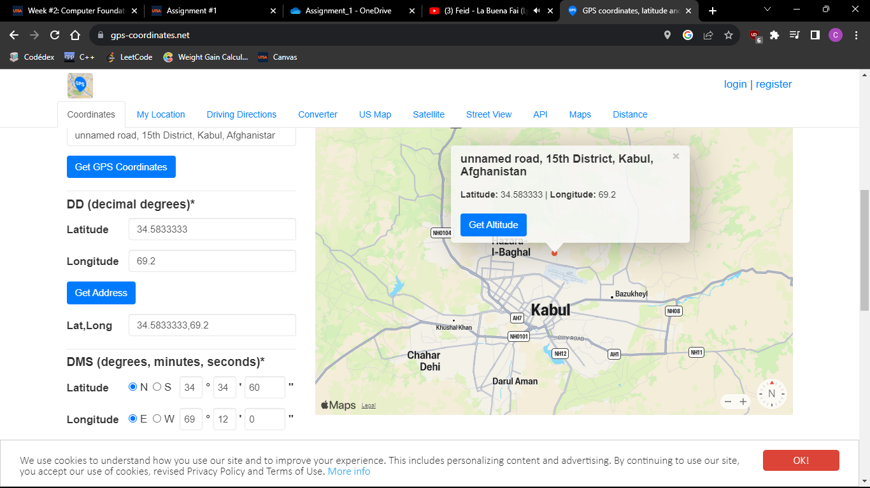What is Obama Bin Laden Jr. location?